BASIC FIVE MARKING SCHEME FOR CREATIVE ARTS
SECTION A
- B 11. A 21. B
- C 12. A 22. C
- B 13. C 23. B
- C 14. C 24. A
- A 15. B 25. A
- C 16. A 26. C
- A 17. B 27. A
- B 18. C 28. A
- B 19. C 29. B
- B 20. B 30. B

SECTION B

1a). Performing art is an art form that is perceived by hearing and seeing.
b)i. Danger/anger
ii. Earth/dead trees
iii. Past, evil
iv. Growth, fresh
v. Love
c). red and blue (the arrangement does not matter)

2a). Red, yellow, green
b). Visual art is the art form that can be seen, felt and touched.
c). ripe
d)i. Sarkodie
ii. Osita Iheme (Paw Paw)
iii. Kwadwo Nkansah (Lil Win)
iv. Grace Omaboe (Maame Donko)
v. Aki
vi. Elliot Kwabena Darko (Obrafour)

3a).
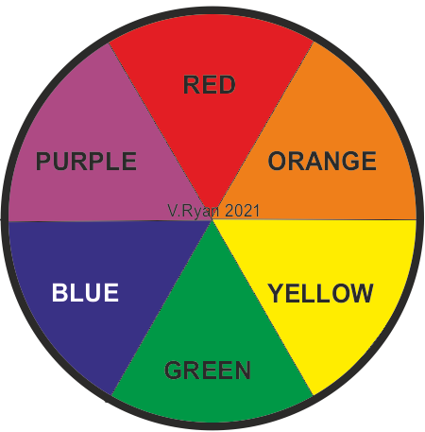

b). Weaving is the process of interlacing two or more strands to form an item.
c)i. Stitching
ii. Knotting

4a)i. Wooden loom
ii. Card loom
iii. Waffle loom
iv. Broad loom

b)i. Red + blue = Purple/violet
ii. Blue + yellow = green

c)i. Proverbs are short wise sayings which educate or advice people.
ii. A poem is a piece of writing that shows or expresses feelings and ideas.

